1. Remove Filter your search  
   Vanues -> Filter your search   
     
   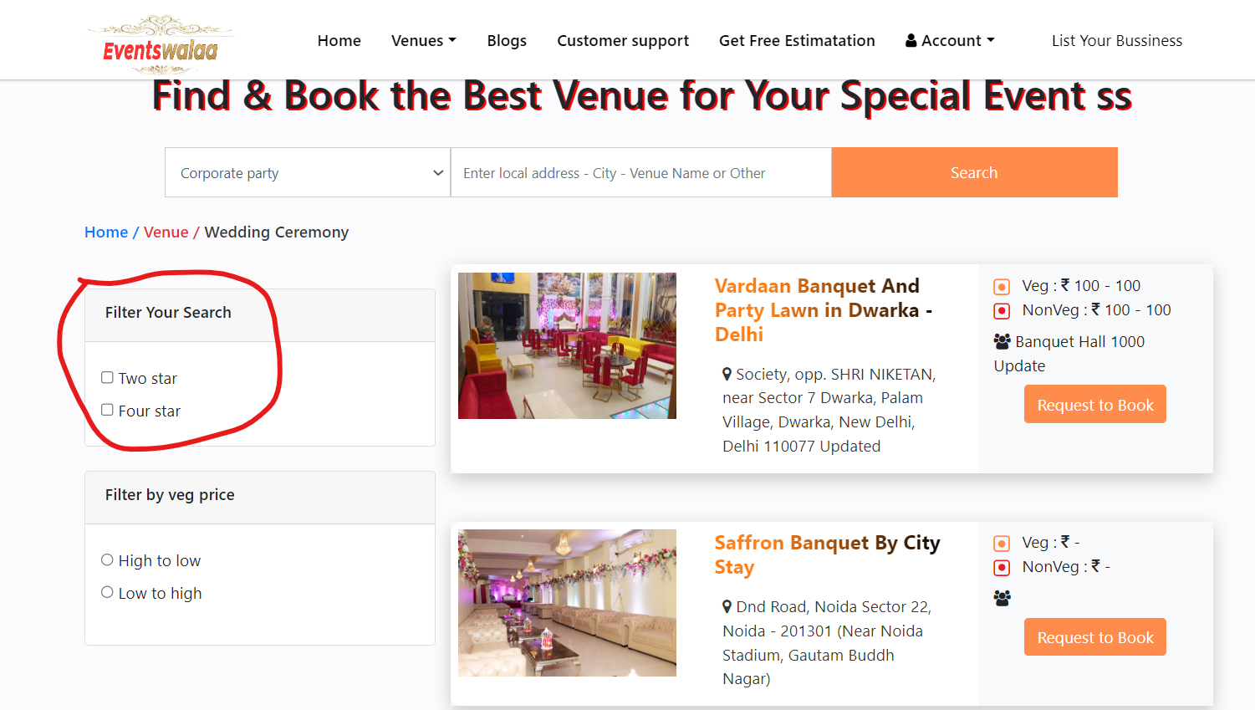
2. Add Event Type instead of filter search. Hotel type will come from hotel table.   
   It should be picklist type.   
   Picklist Name - Event Type  
   Picklist values:- 1. All 2. Hotels 3. Resorts 4. Restaurants 5. Bars and nightclubs 6. Conference centers 7. Theaters
3. Event Type picklist field should be on hotel table also
4. Add Hotel Name on Order table as well as hotel contact number in the below place   
   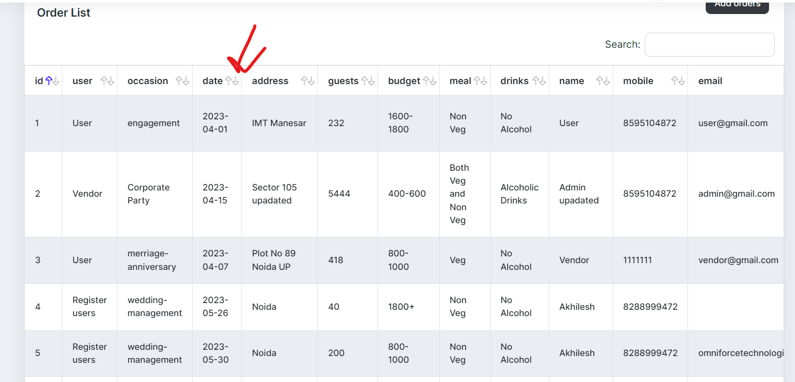
5. 5. Remove popup error message   
   Click on Home Tab -> click on search button without input values.   
   It is showing error as below   
     
   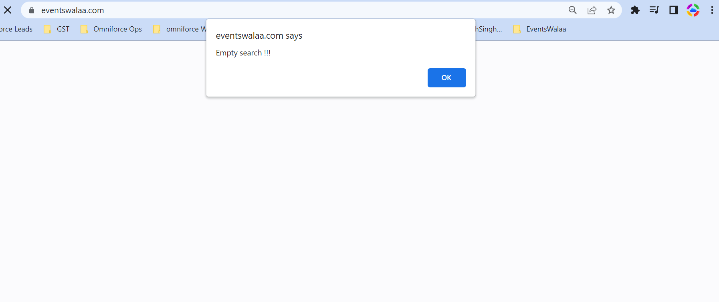
6. Show all nearby hotels when no values comes in filter search instead of Error message like Empty search!!!.
7. Hotel name should be auto fill in input and it should be non editable field  
   Click on vanues -> click on Request to book button   
   